Mbonu Somtochukwu

FACULTY OF COMPUTING

CYBER SECURITY

BHU/22/04/09/0027

CYB202

PROJECT 1

Project One

Objective

Design and implement a computer network for Bingham University, segmented based on different faculties. This includes planning the network topology, IP subnetting, and configuration of network devices.

Task

Identify all the faculties in Bingham University and their departments and present the information in the following format:

Table A

# Faculty Number of departments

1 Faculty of Computing 3

2 Faculty of ABC N

3

You are provided a network 192.168.4.0, you are required to create subnets for each faculty with departments as the nodes (hosts).

a) State the number of bits you will borrow from the Host ID to create the required subnets.

b) Show the bit combinations that are possible from the number of bits borrowed in (a) above.

c) Using the information in (b) compute the range of values for each network (show your work)

d) Using a table, present the network ID, Host ID Range, Number of Usable Host IDs, and Broadcast IDs for each of the networks as generated from (c) (Label this as Table B)

e) Based on the information in Table A, use packet tracer to design the physical network showing the network equipment for each segment of the network.

f) Use data in Table B, generated in (e) to implement the logical network.

Answers:

| **#** | **Faculty name** | **Number of department** |
| --- | --- | --- |
| 1 | Faculty of law | 1 |
| 2 | Faculty of Computing Sciences | 3 |
| 3 | Faculty of Allied Health | 2 |
| 4 | Faculty of Education | 3 |
| 5 | Faculty of Medical Sciences | 7 |
| 6 | Faculty of Arts | 3 |
| 7 | Faculty of Pharmaceutical Sciences | 1 |
| 8 | Faculty of Environmental Sciences | 5 |
| 9 | Faculty of science and technology | 8 |
| 10 | Faculty of Social Sciences | 5 |
| 11 | Faculty of Business Administration | 2 |

A. In this instance 4 bits were borrowed as we need an “ 11 ” IP address. Borrowing 4 bits gave us 16 IP addresses but we will only use 11, derived by using 2^(4) = 16.

B. Table A

| # | Faculty name | IP ADDRESS |
| --- | --- | --- |
| 1 | Faculty of Medical Sciences | 192.168.4.1 |
| 2 | Faculty of Education | 192.168.4.16 |
| 3 | Faculty of Environmental Science | 192.168.4.32 |
| 4 | Faculty of Social Sciences | 192.168.4.48 |
| 5 | Faculty of Pharmaceutical Sciences | 192.168.4.64 |
| 6 | Faculty of Computing Science | 192.168.4.80 |
| 7 | Faculty of Allied-Health | 192.168.4.96 |
| 8 | Faculty of Arts | 192.168.4.112 |
| 9 | Faculty of Business Administration | 192.168.4.128 |
| 10 | Faculty of law | 192.168.4.144 |
| 11 | Faculty of Science and Technology | 192.168.4.160 |

C. The range of values for the network will be 16, as we borrowed 4 bits from the host ID.

2^(4) = 16 IP addresses.

We will online use 14 IP addresses from these 16 as we are exempt from the “ Broadcast ID” and the “ Network ID “

D. Table B

| # | Faculty name | Network_IDs | Range | Usable host_Ids | Broadcast_IDs |
| --- | --- | --- | --- | --- | --- |
| 1 | Faculty of Medical Sciences | 192.168.4.2 | 192.168.4.1 - 192.168.4.14 | 14 | 192.168.4.15 |
| 2 | Faculty of Education | 192.168.4.16 | 192.168.4.17 - 192.168.4.30 | 14 | 192.168.4.31 |
| 3 | Faculty of Environmental Science | 192.168.4.32 | 192.168.4.33 - 192.168.4.46 | 14 | 192.168.4.47 |
| 4 | Faculty of Social Sciences | 192.168.4.48 | 192.168.4.49 - 192.168.4.62 | 14 | 192.168.4.63 |
| 5 | Faculty of Pharmaceutical Sciences | 192.168.4.64 | 192.168.4.65 - 192.168.4.78 | 14 | 192.168.4.79 |
| 6 | Faculty of Computing Science | 192.168.4.80 | 192.168.4.81 - 192.168.4.94 | 14 | 192.168.4.95 |
| 7 | Faculty of Allied-Health | 192.168.4.96 | 192.168.4.97 - 192.168.4.110 | 14 | 192.168.4.111 |
| 8 | Faculty of Arts | 192.168.4.112 | 192.168.4.113 - 192.168.4. 126 | 14 | 192.168.4.127 |
| 9 | Faculty of Business Administration | 192.168.4.128 | 192.168.4.129 - 192.168.4.142 | 14 | 192.168.4.1143 |
| 10 | Faculty of law | 192.168.4.144 | 192.168.4.145 - 192.168.4.158 | 14 | 192.168.4.1159 |
| 11 | Faculty of Science and Technology | 192.168.4.160 | 192.168.4.161 - 192.168.4.174 | 14 | 192.168.4.175 |

We only have 14 usable IP addresses because we must reserve two from the available IP address for the broadcast and network ID’s.

2^(B) - 2 = usable IP address.

where B is bits borrowed.

E.

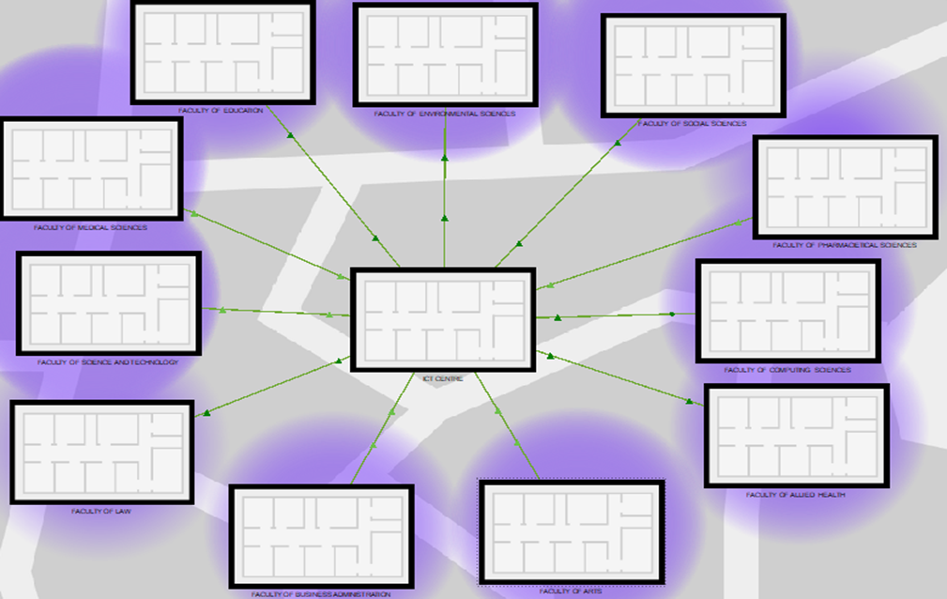

This is the “ Physical View “ of the university.

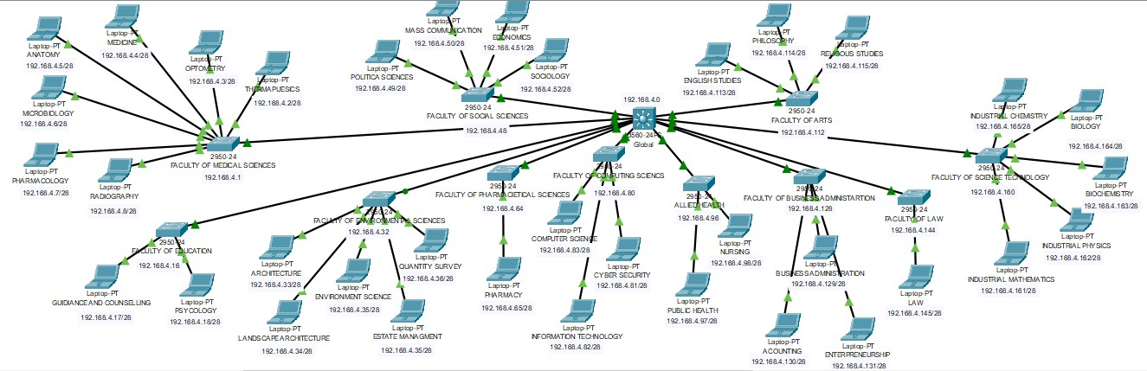

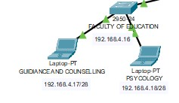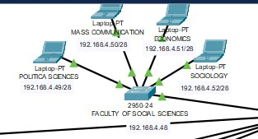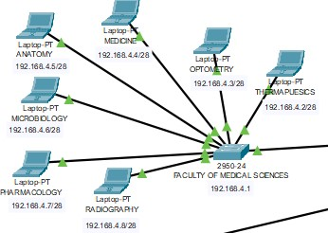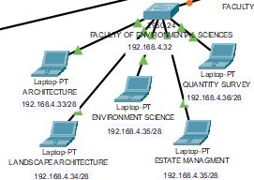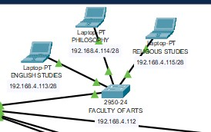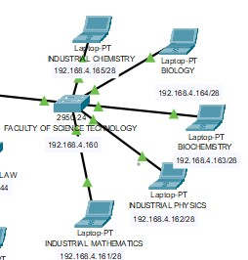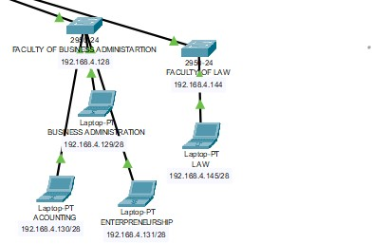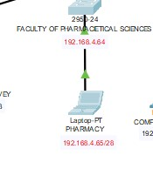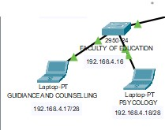

This i the “Network View “ of the University, In this instance,e we use a star topology from the ICT Centre “ Multi-layer Switch” a the center which is then connected to the “ layer-2 Switch ” in each Faculty and finally distributed to “LAPTOPS” for the department.

Here we used the following devices:

- Multi-layer: 3560-24ps (Core layer)

- layer2 Switc: 2950-24 (Distribution layer) (11 for the 11 Faculty)

- layer 1 device: LAPTOPS-PT ( User)(For each department, NODES)

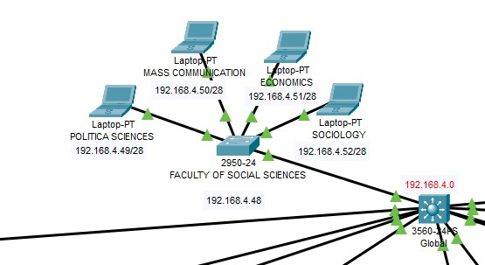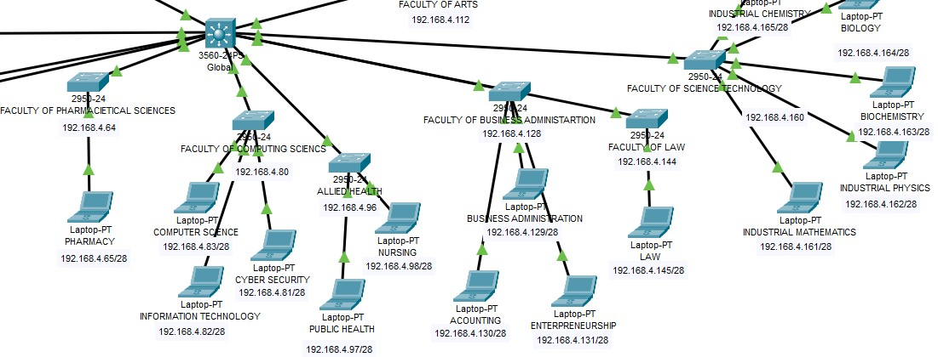

F. We will use this as a case study for the explanation of the logic network.

. First, what devices were used and why?

Here we used the following devices:

For each Range, IP_Addresses 2 cannot be USED, which leaves us with 14 IPs left.

Consider the example A from “Table B”:

# Faculty of Science and Technology 192.168.4.160 192.168.4.161 - 192.168.4.174 192.168.4.175

In the above slot,

- Network_Id : “192.168.4.160 ”,

- Rang: “ 192.168.4.161 - 192.168.4.174 ”

- Broadcast_Id : “ 192.168.4.175 ”

**------**>Configurations were made in each layer to create VLANs to connect the Core to the Distribution layer, And the Distribution to the Access Layer.

Using a VLAN, in this case (name: “ VLAN110 “ ), we created a VLAN for each **Faculty** and allocated an IP_Address to each VLAN.

- Core Layer: Cisco Catalyst 3560-24PS(Configuration):

”””

**.enable**

**.configure terminal**

**.ip routing**

**.vlan 110**

**.hostname core**

**.name Faculty_SciTech  
.interface vlan 110**

**.ip address 192.168.4.161 255.255.255.240**

**.no shutdown  
”””**

**—------**>This Created a VLAN in the **Core layer,** and through an ethernet cable the **Core** Device was connected to the **Distribution layer device**.  
**- ”””**

**.enable**

**.configure terminal**

**.vlan 110**

**. interface FastEthernet0/1**

**.ip address 192.168.4.162 255.255.255.240**

**.switchport mode trunk**

**.switchport trunk allowed vlan all**

”””

**—------**>This allocated the vlan to a Specific “PORT, in the case ”FastEthernet0/1, on the **Distribution layer** Device which was then connected to the **Access layer devices**. This process would be repeated for all 11 Faculties.

**-“””**

**enable**

**configure terminal**

**VLAN 10**

**name Faculty1**

**VLAN 20**

**name Faculty2**

**# ... continue for other faculties  
”””**

Finally, the **Access layer devices** would be configured.

“””

Laptop1: IP address 192.168.4.164

Laptop2: IP address 192.168.4.165

“””

. Explanation of trunk and use: A trunk is a link between two network devices (typically switches) that can carry multiple VLANs simultaneously. It's like a highway with multiple lanes, each lane carrying different types of traffic (VLANs).